**Student Name – De Silva APC**

**Index Number – 210098R**

**Assigned Lab tasks –**

designing and developing simple Assembly programs to achieve given objectives, interface simple input and output devices to the microprocessor and finally verifyng their functionality via simulation using “smz32” was the core target of the lab. In the process its asked to first to read the documentation and then go through some sample implementations. Then we were been asked to modify some codes given to implement some functionalities such as two traffic lights and a seven segment displays that display last two digits of my index number and afterwards the multiplication result of numbers from 1 to 5.

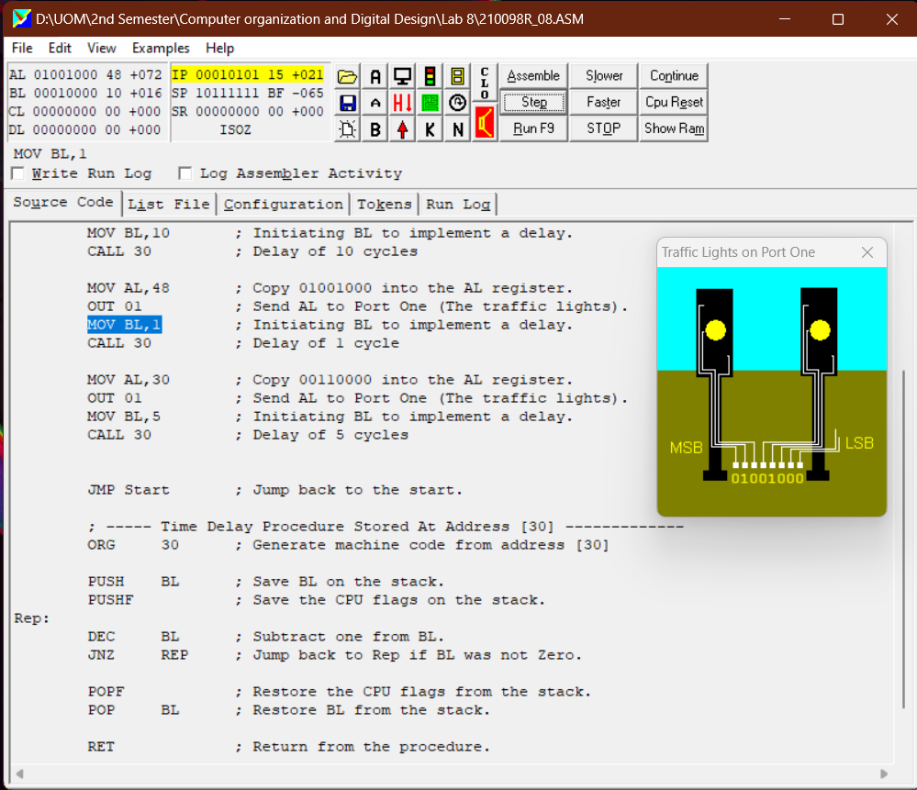

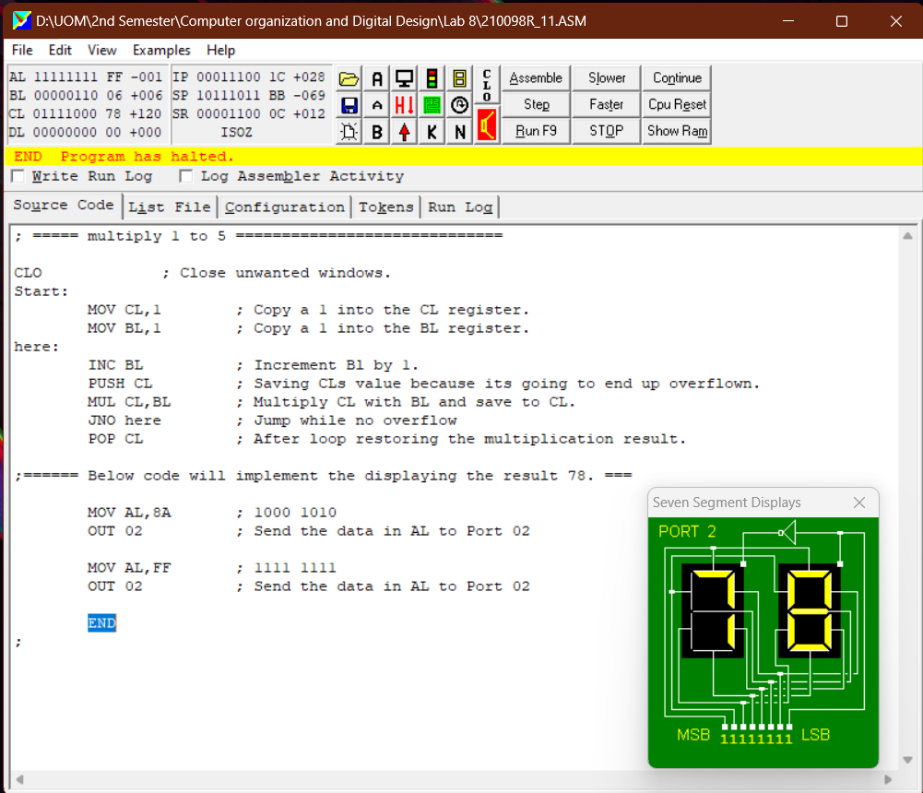

**01FIRSTAdd.asm**

; ===== WORK OUT 2 PLUS 2 ======================================

CLO ; Close unwanted windows.

MOV AL,3 ; Copy a 3 into the AL register.

MOV BL,6 ; Copy a 6 into the BL register.

ADD AL,BL ; Add AL to BL. Answer goes into AL.

END;

; ===== Program Ends ===========================================

**01FIRSTSub.asm**

; ===== WORK OUT 2 PLUS 2 ======================================

CLO ; Close unwanted windows.

MOV BL,7 ; Copy a 7 into the BL register.

MOV CL,3 ; Copy a 3 into the CL register.

SUB CL,BL ; Substract BL from CL. Answer goes into CL.

END;

; ===== Program Ends ===========================================

**01FIRSTMul.asm**

; ===== WORK OUT 2 PLUS 2 ======================================

CLO ; Close unwanted windows.

MOV BL,7 ; Copy a 7 into the BL register.

MOV DL,10 ; Copy a 10 into the DL register.

MUL DL,BL ; Multiply DL and BL. Answer goes into DL.

END;

; ===== Program Ends ===========================================

**01FIRSTDiv.asm**

; ===== WORK OUT 2 PLUS 2 ======================================

CLO ; Close unwanted windows.

MOV DL,13 ; Copy a 6 into the DL register.

MOV AL,7 ; Copy a 7 into the AL register.

DIV DL,AL ; Divide DL by AL. Answer goes into DL.

END;

; ===== Program Ends ===========================================

**210098R_08.asm**

; ===== CONTROL THE TRAFFIC LIGHTS =============================

CLO ; Close unwanted windows.

Start:

; Turn off all the traffic lights.

MOV AL,0 ; Copy 00000000 into the AL register.

OUT 01 ; Send AL to Port One (The traffic lights).

; Turn on all the traffic lights.

MOV AL,84 ; Copy 10000100 into the AL register.

OUT 01 ; Send AL to Port One (The traffic lights).

MOV BL,10 ; Initiating BL to implement a delay.

CALL 30 ; Delay of 10 cycles

MOV AL,48 ; Copy 01001000 into the AL register.

OUT 01 ; Send AL to Port One (The traffic lights).

MOV BL,1 ; Initiating BL to implement a delay.

CALL 30 ; Delay of 1 cycle

MOV AL,30 ; Copy 00110000 into the AL register.

OUT 01 ; Send AL to Port One (The traffic lights).

MOV BL,5 ; Initiating BL to implement a delay.

CALL 30 ; Delay of 5 cycles

JMP Start ; Jump back to the start.

; ----- Time Delay Procedure Stored At Address [30] -------------

ORG 30 ; Generate machine code from address [30]

PUSH BL ; Save BL on the stack.

PUSHF ; Save the CPU flags on the stack.

Rep:

DEC BL ; Subtract one from BL.

JNZ REP ; Jump back to Rep if BL was not Zero.

POPF ; Restore the CPU flags from the stack.

POP BL ; Restore BL from the stack.

RET ; Return from the procedure.

END ; Program ends.

**210098R_10.asm**

; ======================================================

; ===== 99sevseg.asm ===================================

; ===== Seven Segment Displays Port 02 =================

Start:

MOV AL,DE ; 1101 1110

OUT 02 ; Send the data in AL to Port 02

MOV AL,FF ; 1111 1111

OUT 02 ; Send the data in AL to Port 02

END

; ======================================================

**210098R_11.asm**

; ===== multiply 1 to 5 =============================

CLO ; Close unwanted windows.

Start:

MOV CL,1 ; Copy a 1 into the CL register.

MOV BL,1 ; Copy a 1 into the BL register.

here:

INC BL ; Increment Bl by 1.

PUSH CL ; Saving CLs value because its going to end up overflown.

MUL CL,BL ; Multiply CL with BL and save to CL.

JNO here ; Jump while no overflow

POP CL ; After loop restoring the multiplication result.

;====== Below code will implement the displaying the result 78. ===

MOV AL,8A ; 1000 1010

OUT 02 ; Send the data in AL to Port 02

MOV AL,FF ; 1111 1111

OUT 02 ; Send the data in AL to Port 02

END

;